1. **Install environment**

Install Python version 3.6

Install PyCharm Professional Edition / VS Code for programming

This tutorial provides a setup example using Pycharm

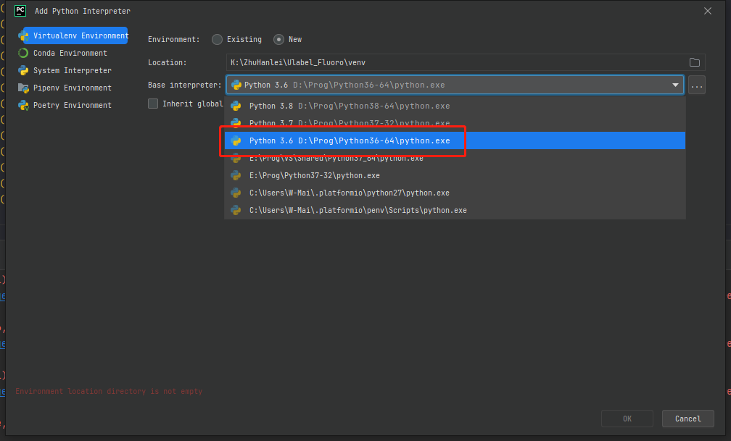

Figure 1 Choose Python interpreter

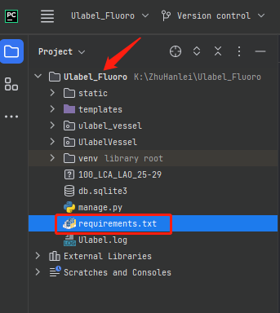

Figure 2 Drag the requirements.txt document into the Ulabel_Fluoro path

Use the following command to install the required libraries. “pip install -r requirements.txt”

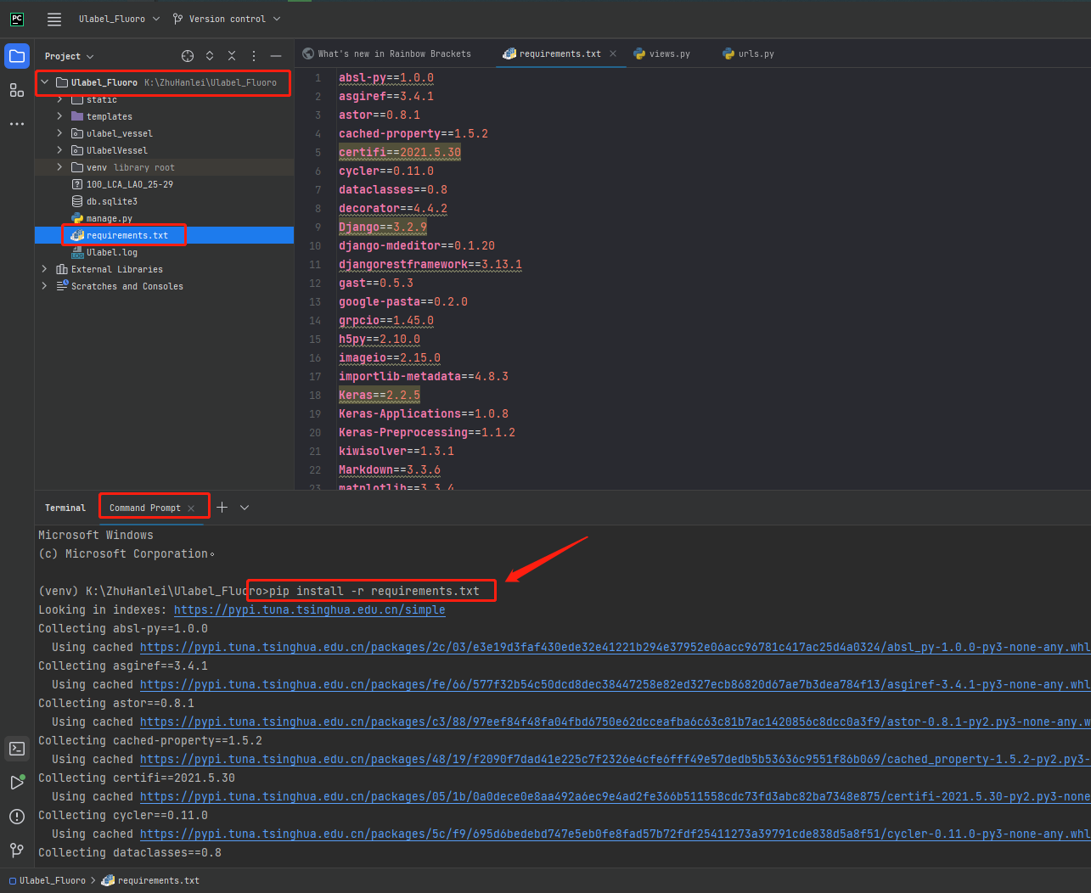

Figure 3 Enter the command in the terminal to install the required libraries in the requirements.txt file

1. **Operating system**

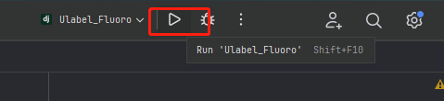

Figure 4 click to start the server

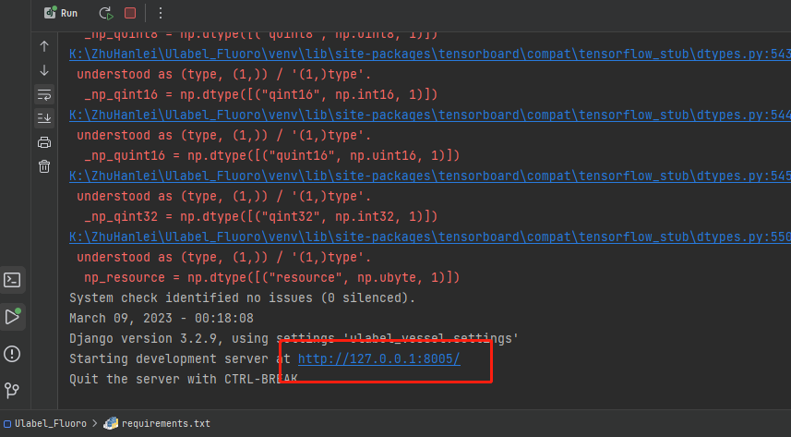

Figure 5 Copy the above link and {link}/login/ to open UlabelFluoro in browser

* 1. **Login interface**

Login to use the system. New user needs to sign up an account.

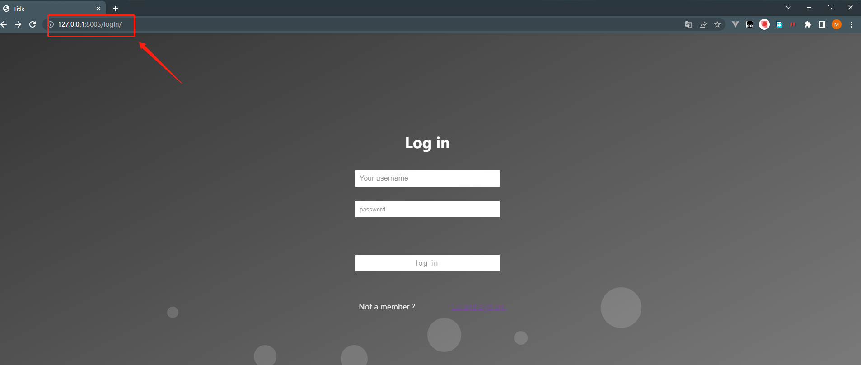

Figure 6 log in after registration

**1.2 Upload data interface**

Click ‘Select dicom files’ to upload a coronary angiography, as shown in Figure 7. More than one DICOM files can be uploaded simultaneously. Then click ‘Upload’ button to start uploading the data. The ‘success’ means the DICOM file is successfully uploaded. Finally, click the ‘ULabel_Fluoro’ button to jump to the annotation page.

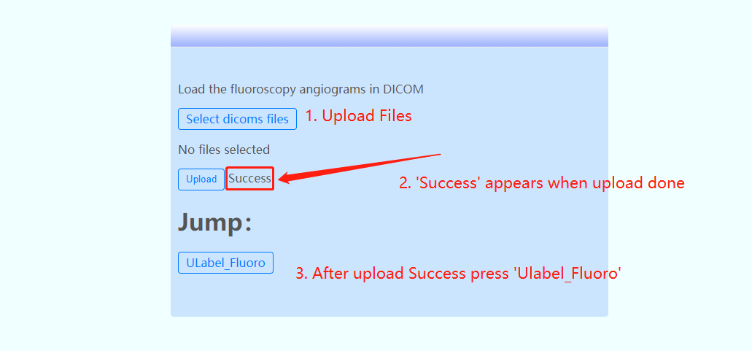

Figure 7 Upload data

**1.3 Select key frames**

This page is used to allow the user to select a specific frame from the coronary angiography video that the user is going to annotate. The buttons are shown in the left panel, which can be used to switch the coronary angiography frames. The ‘Select button’ is used to select the key frames. After selecting one or more key frames, click the ‘Predict button’ to invoke the trained U-Net++ model to automatically predict binary arterial segmentation image, as shown in Figure 8.

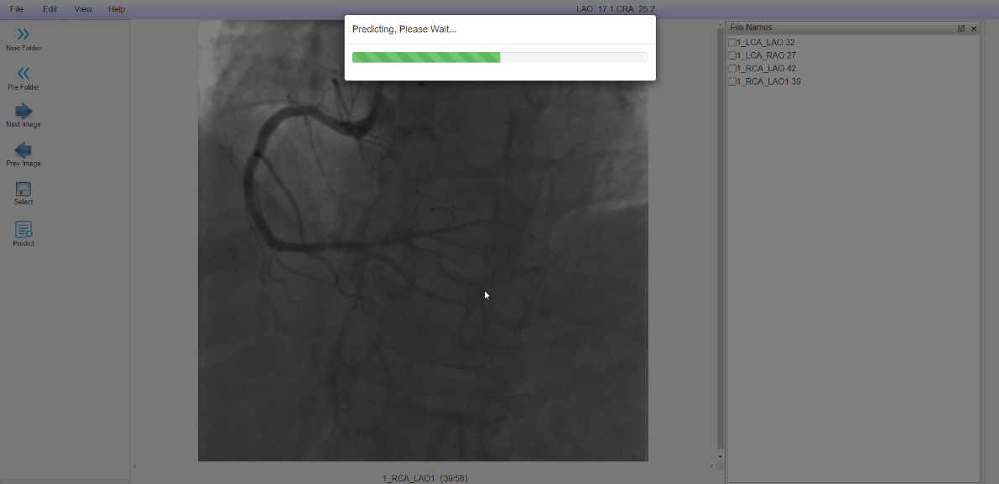

Figure 8 Use the trained model to predict the binary arterial segmentation image

**1.4 Modifying the binary segmentation results**

The page can be used to add arteries, through brush and fill tools. (Figure 9, 10)

Ulabel Fluoro keyboard shortcuts

Q（-） E（+） Adjust the thinkness of the brush or eraser

W Show/Hide Canvas (Vessels)

S Withdraw

A Zoom out the picture

D Zoom in the picture

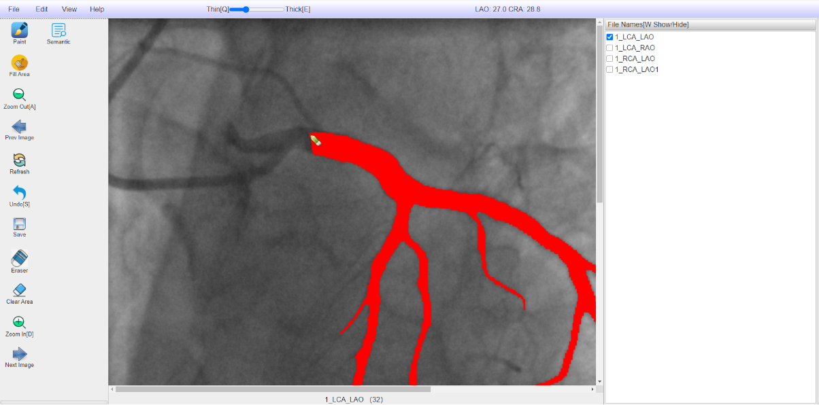

Figure 9 Brush operation after zooming in

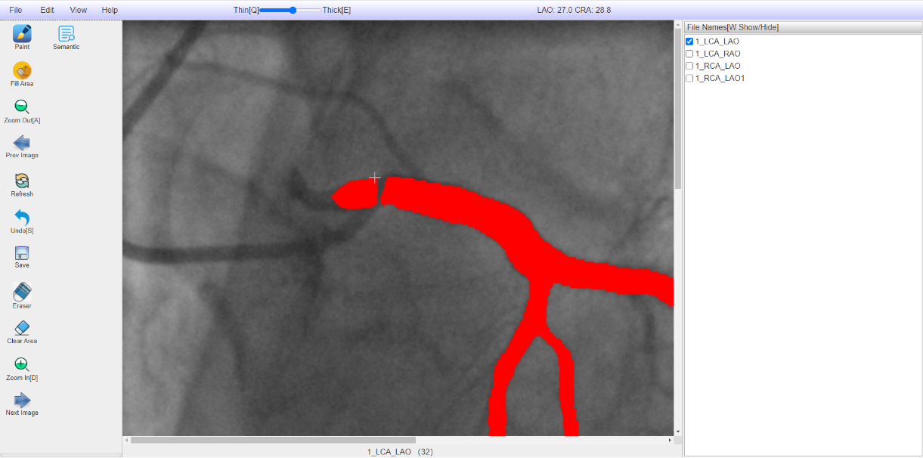

Figure 10 Fill area

Modifying the predicted arteries, or remove non-target arteries, can be achieved by erasing and clearing RoIs. (Figure 11, 12)

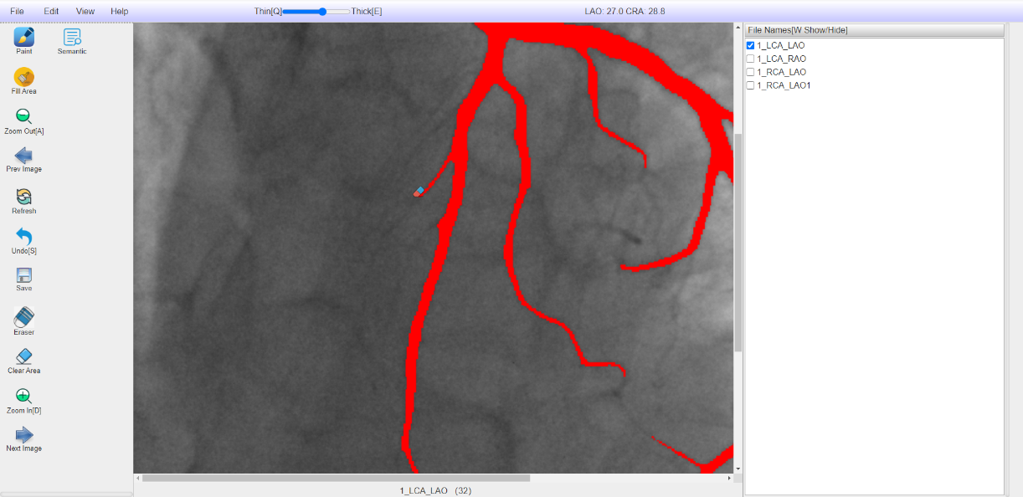

Figure 11 Remove interface with eraser

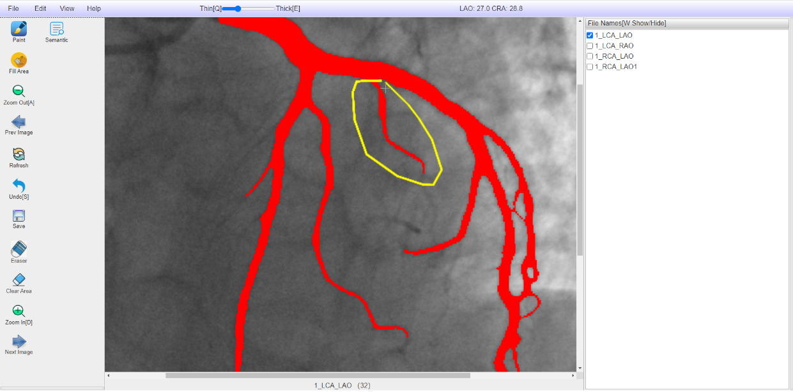

Figure 12 Clear area

**1.5 Artery semantic labeling interface**

This page is to assign semantic labels to each of the coronary arteries , store pixel information, and display them in pseudo colors. The upper right is the file name of the angiography, and the lower right is the arteries that have been annotated. Users can click the corresponding check boxes for preview, as shown in Figure 13.

To annotate the coronary arteries, the connection of arteries should be carefully drawn, and the starting point should be annotated accurately.

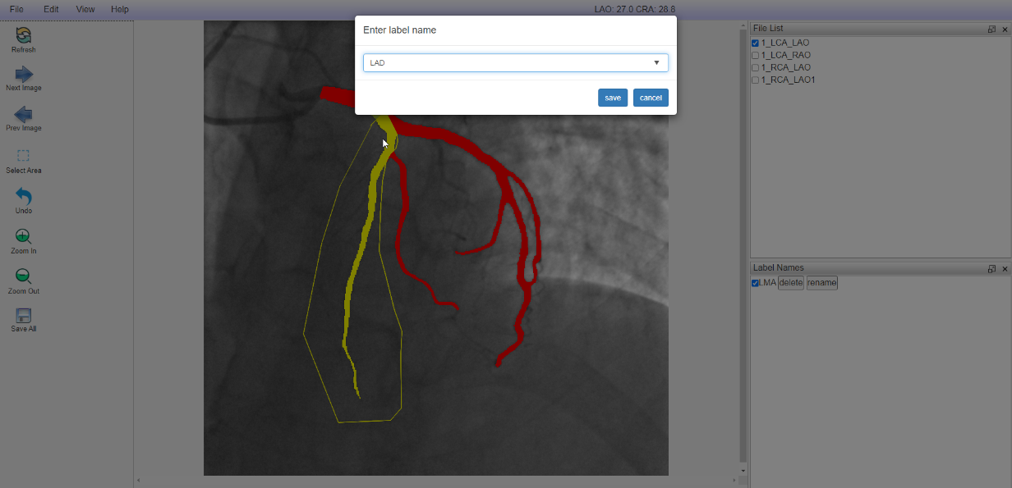

Figure 13 Label blood vessels

**1.6 Data download**

After annotating all arteries, click Save All to download the results. (Figure 14)

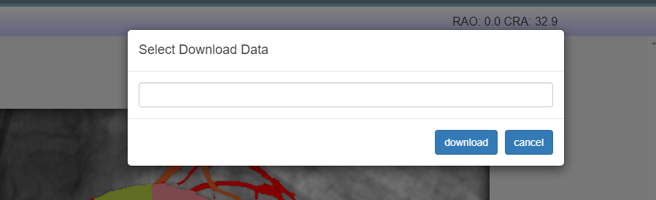

Figure 14 Download data